**את"מ מעבדה 4:  
  
מגישים:  
 אורי מלכא- 314862996   
אלן ציפין- 313206062  
  
תרגיל 1:**;

;

.MODEL SMALL

.STACK 100h

.DATA

;Var

N DB 3

ARR1 DB 0,0,0

ARR2 DB 0,0,0

.CODE  
 ProgStart:

MOV AX,@DATA

MOV DS,AX ; Set DS to point to data segment

;DI,SI Pointers to the Arrays.

MOV DI,OFFSET ARR1

MOV SI,OFFSET ARR2

ToStart:

CMP N,0

JE ToEnd

MOV AL,N

MOV BYTE PTR[DI],AL

ADD AL,'0' ;For the ASCII CODE.

MOV BYTE PTR[SI],AL

DEC N ;N--

INC DI ;DI ++

INC SI ;SI ++

JMP ToStart

ToEnd:

MOV AH,4Ch ; Set terminate option for int 21h

INT 21h ; Return to DOS (terminate program)

;

END ProgStart ; Set "ProgStart:" as first executable statement

פלטים תרגיל  
  
  
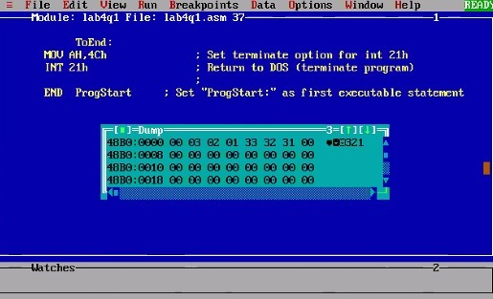  
  
  
  
  
  
  
  
  
  
  
  
  
  
  
  
  
  
  
  
  
  
  
  
  
  
  
  
  
  
**תרגיל 2:**

;

.MODEL SMALL

.STACK 100h

.DATA

;Var

SUM DD 0

ARR DW 1234,9999,1111,4444

T DD 10 ; for div

;Strings

DisplayString DB 'Last digit in the sum is:X',13,10, '$'

.CODE

ProgStart:

MOV AX,@DATA

MOV DS,AX ; Set DS to point to data segment

.386

;DI, pointer to the array.

MOV DI,OFFSET ARR

MOV CX,4

LoopStart:

MOV EAX,0

MOV AX,[DI] ;EAX=ARR[I]

MUL EAX ; EDX:EAX=EAX^2

ADD SUM,EAX ; As we were told we assume that the size of EAX^2 is compatible in 32bit.

ADD DI,2

LOOP LoopStart

MOV EDX,0

MOV EAX,SUM

DIV T ; EDX=EDX:EAX % T => EDX= 0:SUM % 10 => EDX= SUM%10//

ADD EDX,'0'

MOV DisplayString[25],DL

;to print the display string

MOV AH,9

MOV DX,OFFSET DisplayString

INT 21h

ToEnd:

MOV AH,4Ch ; Set terminate option for int 21h

INT 21h ; Return to DOS (terminate program)

;

END ProgStart ; Set "ProgStart:" as first executable statement

פלטים תרגיל 2:  
  
  
עבור 1,23,450,67  
  
  
   
  
1234,9999,1111,4444  
  
  
  
עבור 60000,1,1,1  
  
